Explicit method to solving angle calibration functions of dual mirror laser galvonometer

Owen Lu

Electroimpact Inc.

owenl@electroimpact.com

*Abstract*— It was thought that galvanometer angles within AGS laser projects were known by measurement however, it has been revealed that this is not the case. Thus, although the galvanometer relationship between digital command rotation is approximately linear, the angle must be inferred via calculation and rays generated using a mathematical model. This document outlines how such calibration functions can be inferred in the absence of measurement.

# Introduction

The problem, which has yet to be proven in a mathematical sense, is summarized in this basic statement:

Knowing the projector geometry you can solve for the angle pair that generates a ray $r$ through some point $x_{0}$. Knowing the angle pair that generates $r$ through some point $x_{0}$ you can solve for the geometry of the projector. Knowing neither the geometry nor the angle pair, there are infinite solutions for both the angle pair and projector geometry that produces $r$ that passes through $x_{0}$.

However, what this statement does not include is the assumption that the DAC angles can be converted to angles perfectly through a linear relationship. This is the most important overarching assumption in this model.

# Forward kinematic assumption

Previously, laser kinematic equations have been derived to describe the ray output of the second mirror. Thus, assuming some projector geometry the ray is a function of only two variables $(θ_{1},θ_{2})$. The geometry is the exact geometry used as reference in the projector design drawings and is referred to as nominal dimensions.

The ray $r$ is described with the equations below.

$${\overline{p}}^{'}=\left(\begin{matrix}x_{1}-y_{1}\cot\left(θ_{1}\right)-\frac{t_{1}}{2\sin\left(θ_{1}\right)} \\ 0 \\ 0\end{matrix}\right)$$

$${\overline{p}}^{''}={\overline{p}}^{'}+\left(\begin{matrix}\left(y_{2}-z_{2}\cot\left(θ_{2}\right)-\frac{t_{2}}{2\sin\left(θ_{2}\right)}\right)\cot\left(2θ_{1}\right) \\ y_{2}-z_{2}\cot\left(θ_{2}\right)-\frac{t_{2}}{2\sin\left(θ_{2}\right)} \\ 0\end{matrix}\right)$$

$${\overline{u}}^{''}=\left(\begin{matrix}cos⁡(2θ_{1}) \\ \sin\left(2θ_{1}\right)cos⁡(2θ_{2}) \\ \sin\left(2θ_{1}\right)\sin\left(2θ_{2}\right)\end{matrix}\right)$$

The ray in galvanometer coordinates, defined as frame B is given below.

$$r={\overline{p}}^{''}\left(θ_{1},θ_{2}\right)+λ{\overline{u}}^{''}(θ_{1},θ_{2})$$

Thus, solving the system of 3 equations below will generate the inferred angle pair, with corresponding ray length $λ$.

$${\overline{p}}^{''}\left(θ_{1},θ_{2}\right)+λ{\overline{u}}^{''}\left(θ_{1},θ_{2}\right)-x_{0}=0$$

# Linearity assumption

In order to convert the DAC readings to mirror angles a simple linear formula is assumed where mirror angle

$$θ_{1}=k_{1}DAC_{1}+b_{1}$$

$$θ_{2}=k_{2}DAC_{2}+b_{2}$$

Constants $k_{1},b_{1},k_{2},b_{2}$ are all constructed by solving the system for $(θ_{1},θ_{2})$ and curve fitting the relationship vs. DAC readings.

# Error calculation

The error in the angles is calculated with the formula below.

$$δθ_{1}={θ_{1}}_{i}-k_{1}DA{C_{1}}_{i}-b_{1}$$

$$δθ_{2}={θ_{2}}_{i}-k_{2}DA{C_{2}}_{i}-b_{2}$$

Ideally random error would be the cause for $δθ$ disagreements. However, projector geometry is not perfect, and the main factor, which is mirror misalignment causes $δθ_{1}$ and $δθ_{2}$ to be functions of both DAC readings.

$$δθ_{1}=f\left(DAC_{1},DAC_{2}\right)$$

$$δθ_{2}=g\left(DAC_{1},DAC_{2}\right)$$

This phenomenon must be further studied as understanding these plots in relation to the mirror misalignment may yield vastly more accurate theoretical results. Possible changes in the experimental procedure may be necessary to determine such relationships.

# Test results

AGS has provided 10ft calibration data along with their own algorithm error report. In general, the projector is calibrated at one distance and the error is reported as the RMS difference between the point in space the laser intersection on a corresponding z-plane. It has been discussed to instead use ray to point perpendicular distance instead of constraining error to be in-plane, as this is an arbitrary constraint that inflates the error.

However, for purpose of comparison, the same AGS error algorithm is used.

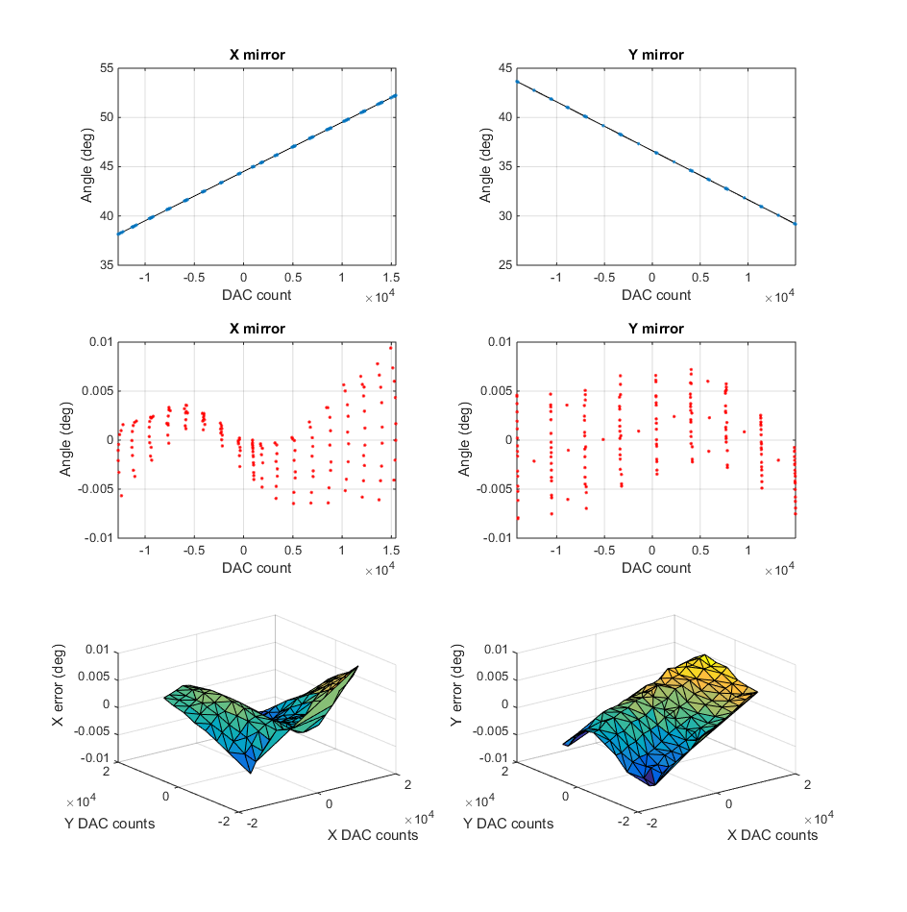

Using a 4th order polynomial in two variables, a fit was constructed to the error in order to correct the angles in the least squares sense. The overall performance of the algorithm to predict the location of the laser ray outperformed the AGS algorithm by 37% for RMS error and 30% standard deviation. However, work is being done to construct an error curve fit of a specific form dependent on real geometric characteristics.